Sports injury and illness recording application (SIRA)

แอปพลิเคชันบันทึกอาการบาดเจ็บและการเจ็บป่วยทางการกีฬา

BY

Mr. Krissanapong Palakham 6288102

Mr. Pongsakorn Piboonpongpun 6288107

Mr. Rathakit sriprachayanun 6288134

ADVISOR

asst. prof. Dr. charnyote pluempitiwiriyawej

A Senior Project Submitted in Partial Fulfillment of

the Requirements for

THE DEGREE OF BACHELOR OF SCIENCE

(INFORMATION AND COMMUNICATION TECHNOLOGY)

Faculty of Information and Communication Technology

Mahidol University

2022

**COPYRIGHT OF MAHIDOL UNIVERSITY**

ACKNOWLEDGEMENTS

We really would like to thank everyone who has taken part in our initiative and was relevant. This project could not be completed without the participation of all of the participants, including Mr. Krissanapong (Pun), Mr. Pongsakorn (Mark), and Mr. Rathakit Sriprachayanun (Art). We were also grateful to Asst. Prof. Dr. Charnyote Pluempitiwiriyawej, who served as our principal advisor for his invaluable assistance, and to all of the advisors from the Faculty of Information and Communication Technology and the Faculty of Sports Sciences for their support. We could learn a lot from this endeavor and put what we have learned into practice as we completed the final report. Finally, we expected that our project would be entirely useful, and grateful as well as thanks to our parents encouraged us with their special support.

Mr. Krissanapong Palakham

Mr. Pongsakorn Piboonpongpun

Mr. Rathakit Sriprachayanun

Sports injury and illness recording application

Mr. Krissanapong Palakham 6288102 ITCS/B

Mr. Pongsakorn Piboonpongpun 6288107 ITCS/B

mr. rathakit sriphachayanun 6288134 ITCS/B

B.Sc. (INFORMATION AND COMMUNICATION TECHNOLOGY)

PROJECT ADVISOR: asst. prof. dr. charnyote pluempitiwiriyawej

ABSTRACT

This project is an application project with the purpose of collecting data on illnesses and injuries which are important problems for athletes and recording staff data to record their data. Athletes can be timely by collecting data of athletes that will be saved in paper or google form where it is likely to be lost and compiled to be difficult to use. Our application is built to record and track injuries and illnesses through the Oslo Sports Trauma Research Center (OSTRC) Questionnaire and the International Olympic Committee (IOC) Injury and Illness Record that will be shown to the athletes as scores and messages. If the score exceeds the OSTRC star criteria, staff can see the case scores of the athletes who exceed the criteria, they can record and send messages to the athletes so that athletes can receive treatment, relieve injuries and prevent athletes from using their bodies during training or competition.

KEYWORDS: injury/illness/psychology/athlete/staff/

application/recording

74 P.

แอปพลิเคชันบันทึกอาการบาดเจ็บและการเจ็บป่วยทางการกีฬา

กฤษณพงศ์ ปาลคำ 6288102 ITCS/B

พงศกร พิบูลพงศ์พันธ์ 6288107 ITCS/B

รัฐกฤษฏิ์ ศรีปรัชญานันท์ 6288134 ITCS/B

วท.บ. (เทคโนโลยีสารสนเทศและการสื่อสาร)

อาจารย์ที่ปรึกษาโครงการ: ผศ. ดร. ชาญยศ ปลื้มปิติวิริยะเวช

บทคัดย่อ

การทำโครงงานครั้งนี้เป็นโครงงานทำแอพพลิเคชั่นโดยมีวัตถุประสงค์เพื่อใช้สำหรับการเก็บข้อมูลอาการเจ็บป่วยและอาการบาดเจ็บซึ่งเป็นปัญหาสำคัญต่อนักกีฬาและการบันทึกข้อมูลของบุคลากรเพื่อบันทึกข้อมูลของนักกีฬาได้ทันท่วงทีโดยการเก็บข้อมูลของนักกีฬานั้นจะถูกบันทึกไว้ในกระดาษหรือแบบฟอร์มกูเกิล (Google form) ซึ่งมีโอกาสสูญหายและเรียบเรียงนำมาใช้งานได้ยาก แอปพลิเคชันของเราสร้างเพื่อบันทึกและติดตามอาการบาดเจ็บรวมถึงอาการเจ็บป่วยโดยผ่านแบบสอบถามตาม Oslo Sports Trauma Research Center (OSTRC) และบันทึกข้อมูลอาการบาดเจ็บตาม International Olympic Committee (IOC) ซึ่งจะแสดงให้นักกีฬาได้เห็นเป็นคะแนนและข้อความโดยหากคะแนนนั้นเกินเกณฑ์ OSTRC บุคลากรจะสามารถเห็นเคสคะแนนของนักกีฬาที่คะแนนเกินเกณฑ์และสามารถบันทึกและส่งข้อความให้แก่นักกีฬาเพื่อให้นักกีฬาสามารถได้รับการรักษา, บรรเทาอาการบาดเจ็บและป้องกันการใช้ร่างกายของนักกีฬาในตอนฝึกซ้อมหรือการแข่งขัน

74 หน้า

**CONTENTS**

Page

ACKNOWLEDGEMENTS ii

ABSTRACT iii

LIST OF TABLES vii

LIST OF FIGURES viii

1. Introduction 1

1.1 Motivation 1

1.2 Problem Statement 1

1.2.1 Recording with Paper 2

1.2.2 Recording with Google Form 2

1.3 Objectives of the Project 2

1.4 Scope of the Project 2

1.5 Expected Benefits 3

1.6 Organization of the Document 3

1. Background 5

2.1 Background Knowledge 5

2.1.1 The International Olympic Committee Surveillance Form 5

2.1.2 The Oslo Sports Trauma Research Center Questionnaire Form 5

2.2 Literature Review 14

2.2.1 The health problems survey from the Oslo Sports Trauma Research Center 14

2.2.2 Better reporting of sports-related overuse injuries and health issues 14

2.2.3 Overuse injury questionnaire methodology improvement 14

2.2.4 Material and Method for Oslo Sports Trauma Research Center Questionnaire on health problem 15

2.2.5 Translation and adaptation of Oslo Sports Trauma Research Center into Thai language 15

2.2.6 Sports injuries and illnesses medical record form during Olympic Games 2012 16

1. Analysis and Design 17

3.1 System Architecture Overview 17

3.2 System Structure Chart 20

3.3 Process Analysis and Design 24

3.3.1 Data Flow Diagram 24

3.3.2 Data Dictionary 27

3.4 Database Analysis and Design 36

3.4.1 ER-Diagram 37

3.4.2 Relational Schema 38

3.4.3 File Structure 42

3.5 I/O Design 57

3.5.1 Interface Design 57

REFERENCES 64

BIOGRAPHIES 66

LIST OF TABLES

Page

Table 2.1: Thai and English in OSTRC Health questionnaires 6

Table 2.2: Thai and English in OSTRC Overuse questionnaires 9

Table 2.3 Thai and English in Sport psychology questionnaires 12

Table 3.1: List of all Processes 27

Table 3.2: Process Description of Log on to the application authentication 28

Table 3.3: Process Description of Complete the questionnaire 28

Table 3.4: Process Description of Notify cases 29

Table 3.5: Process Description of Complete the medical record 29

Table 3.6: Process Description of Notify status and advice messages 29

Table 3.7: Process Description of Retrieve result questionnaire history 30

Table 3.8: Process Description of Retrieve result records and cases 30

Table 3.9: List of all Data Stores 31

Table 3.10: Data Store Description of Users database 31

Table 3.11: Data Store Description of Questionnaire database 32

Table 3.12: Data Store Description of Medical record database 32

Table 3.13: Data Store Description of Medical record database 32

Table 3.14: List of All Data Elements 33

Table 3.15: List of all Tables in Our System Database 38

Table 3.16: File Structure of Athlete 43

Table 3.17: File Structure of Staff 45

Table 3.18: File Structure of Health questionnaire 46

Table 3.19: File Structure of Physical questionnaire 48

Table 3.20: File Structure of Illness record 50

Table 3.21: File Structure of Injury record 52

Table 3.22: File Structure of Illness record 54

Table 3.23: File Structure of Message 56

LIST OF FIGURES

Page

Figure 2.1: The example of IOC injury record form 5

Figure 2.2: The example of IOC illness record form 5

Figure 3.1: SIRA Systems architecture 17

Figure 3.2: SIRA systems workflow 19

Figure 3.3: Structure chart of SIRA system 21

Figure 3.4: SIRA Data Flow Diagram Level 0 25

Figure 3.5: SIRA Data Flow Diagram Level 1 26

Figure 3.6: Conceptual ER-Diagram of SIRA Database 37

Figure 3.7: Register and Login 57

Figure 3.8 Staff/Athlete Homepage 58

Figure 3.9: Questionnaire page 59

Figure 3.10: Recording page 60

Figure 3.11: Notification page 61

Figure 3.12: History page 62

Figure 3.13: Staff’s case page 63

CHAPTER 1

# Introduction

In this chapter, there are six parts of introduction which are Motivation, Problem Statement, Objectives of the Project, Scope of the Project, Expected Benefits of the Project, and Organization of the Document. Their focus will be on how the application was developed, why there is a need for the application, and what were the benefits of the application.

## Motivation

Nowadays, injuries usually happen whether physical, mental or health, especially for athletes. Injury problems can affect athletes with their training, practice, as well as a competition. Athletes' performance would be decreased, resulting in their winning success in a competition or evenly lacking training. In addition, staff or medical teams (e.g., coaches, doctors, physical therapists, psychologists) would also be affected by athletes’ injuries. Due to athlete’s injury problems, staffs have to create or change a plan to suit the athlete's problem. Thus, it would be difficult to adjust if the athlete’s problem information is sent late. In order to prevent those problems, keeping records of the athlete’s problems as well as medical recordings from diagnostics are important. Collecting the record from both athletes and staff will assist the athletes’ injury problems in order to decrease treatment time, so athletes can heal themselves with the correct method and also understand their injury status and what they need to do. Moreover, staff can plan whether healing, training, or competition for injured athletes. Therefore, building a platform for keeping those records will extremely be useful for both athletes and staff.

## Problem Statement

Recording the athlete’s problems actually happened in Thailand. However, there are two main problems with recording systems:

### Recording with Paper

The paper-based recording has a number of drawbacks, including being hard to find, easily lost, difficult to retrieve, and requiring a large amount of labor. At the moment, we switch to different methods to avoid these issues.

### Recording with Google Form

Google Form recordings are changed methodology from the paper-based. However, this method of recording injuries and illness has also had some problems whether scattered information, data integration, and difficult processing. Thus, this method has to be changed to a new one in order to improve the recording system.

## Objectives of the Project

* Develop a SIRA system capable of managing data on physical injuries, health illnesses, and mental illnesses
* Make athletes know their injury status in order to heal themselves with the correct methodology
* Enable coaches and the medical staff to utilize athlete data to be useful and provide coaching and treatment input to specific athletes

## Scope of the Project

* A mobile platform that can record both athlete’s questionnaires and complaints as well as medical recordings from staff
* The operating systems provide both IOS and Android in order to collect for all athletes and staff data from all user devices
* Applied the Oslo Sports Trauma Research Center (OSTRC) questionnaires and International Olympic Committee (IOC) record form to the systems
* Sending weekly notifications for athletes in order to answer questionnaires every week

## Expected Benefits

In order to build the application, we expected our solution would be assisted to any kind of the users that were categorized into two groups: users and developers. Furthermore, users were classified into three groups including athletes, medical team, and organization agents. The description is as follows:

* Athlete
  + Receiving a recommendation from medical team for healing themselves
  + Regularly receiving health checks with professional medical team
  + Filling out the health questionnaire forms as simple with clearly user interfaces
* Staff
  + Filling out the medical record form as simple with clearly user interfaces
  + Planning for healing, training, competition for injured athletes
* Developers
  + Practicing mobile programming both coding and framework
  + Creating an assistant program for athletes and medical staff
  + Developing an application for both IOS and Android operating systems with Dart language and Google Firebase Services
  + Evolving problem-solving, time management, prioritizing tasks, programming, database management, UX/UI, and presentation skill.

## Organization of the Document

This document consists of 6 chapters including:

1. Introduction – The motivation, problem statements, project objectives, project scopes, expected benefits for both users and developers, and document organization are all contained in the introduction's first chapter, which also introduces the project.
2. Background – Background knowledge, including a literature review, is included in the second chapter.
3. Analysis and Design – The project's analysis and design are presented in the third chapter. It includes details on the project's design, such as a system architecture overview, a system structure diagram, and a design for the web-based service.
4. Implementation – The fourth chapter discusses the implementation and includes information on hardware, system environment, implementation techniques, and implementation guide.
5. Testing and Evaluation – The testing and evaluation process, spread pattern results, and discussion are all found in the fifth chapter.
6. Conclusion – Conclusion, benefits, issues and limitations, and future work are all included in the sixth chapter.

CHAPTER 2

# Background

This chapter includes examples of background knowledge and earlier projects completed by other scholars that we applied some methodology to this project. We gave a summary of the project's content and an example of required knowledge in order to provide more understanding to this project.

## Background Knowledge

### The International Olympic Committee Surveillance Form

During the Olympic Games 2012 in London, the International Olympic Committee (IOC) provided a medical record form for all stakeholders whether common medical staff, physician team, physiotherapist, and so on. In order to prevent danger from injuries, all stakeholders could be finished the medical form and analysis a symptom of athletes. There are two types of report including injury and illness report that each type has a different required information. [1]

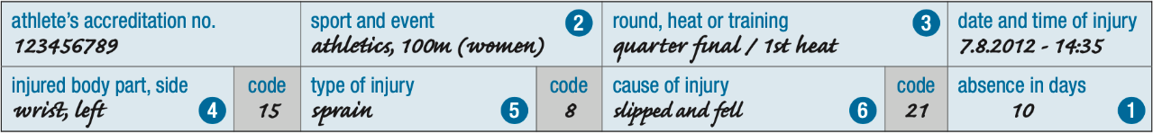

Figure 2.1: The example of IOC injury record form

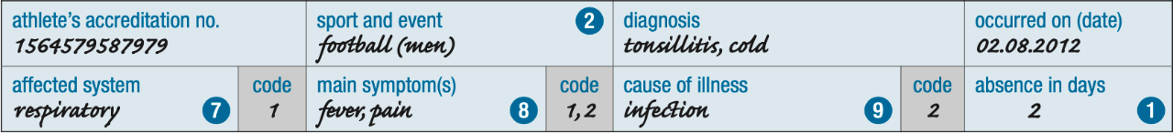

Figure 2.2: The example of IOC illness record form

### The Oslo Sports Trauma Research Center Questionnaire Form

There are questionnaires from the Oslo Sports Trauma Research Center (OSTRC) that are separated into three parts including health, overuse, and sport psychology. The health questionnaire is about the illness of the athletes, for instance, fatigue, fever, and so on. The overuse questionnaire is about the physical injury from any part of the body. The sport psychology questionnaire is about the athletes’ mental illness, for instance, readiness to compete, training, and sleep quality. [2]

Table 2.1: Thai and English in OSTRC Health questionnaires

|  |  |
| --- | --- |
| **Thai version** | **English version** |
| คุณมีปัญหาด้านอาการเจ็บป่วยหรือไม่   * ใช่ * ไม่มี | Do you have an illness problem?   * Yes * No |
| 1. ใน 7 วันที่ผ่านมาปัญหาการบาดเจ็บการเจ็บป่วย หรือปัญหาสุขภาพอื่น ๆ ของท่านทำให้การฝึกซ้อมหรือการ  แข่งขันกีฬามีปัญหาหรือไม่   * เข้าร่วมการฝึกซ้อมหรือแข่งขันกีฬาได้เต็มที่โดยไม่มีปัญหาการบาดเจ็บ,เจ็บป่วย หรือปัญหาสุขภาพ * เข้าร่วมการฝึกซ้อมหรือแข่งขันกีฬาได้เต็มที่แต่มีปัญหาการบาดเจ็บ,เจ็บป่วย หรือปัญหาสุขภาพ * เข้าร่วมการฝึกซ้อมหรือแข่งขันกีฬาได้ไม่เต็มที่เพราะมีปัญหาการบาดเจ็บ,เจ็บป่วย หรือปัญหาสุขภาพ * ไม่สามารถเข้า ร่วมการฝึกซ้อมหรือแข่งขนกีฬาได้ เพราะมีปัญหาการบาดเจ็บ,เจ็บป่วย หรือปัญหาสุขภาพ | Have you had any difficulties participating in normal training and competition due to injury, illness, or other health problems during the past week?   * Full participation without health problems. * Full participation, but with injury/illness. * Reduced participation due to injury/illness. * Cannot participate due to injury/illness. |

|  |  |
| --- | --- |
| **Thai version** | **English version** |
| 2. ใน 7 วันที่ผ่านมา ปัญหาการบาดเจ็บการเจ็บป่วย หรือปัญหาสุขภาพ ของท่านส่งผลกระทบต่อปริมาณการฝึกซ้อมหรือแข่งขันมากน้อยเท่าไหร่   * ไม่ลดลง * ลดลงเล็กน้อย * ลดลงปานกลาง * ลดลงอย่างมาก * ไม่สามารถเข้าร่วมได้เลย | To what extent have you reduced you training volume due to injury, illness, or other health problems during the past week?   * No reduction * To a minor extent * To a moderate extent * To a major extent * Cannot participate at all |
| 3. ใน 7 วันที่ผ่านมา ปัญหาการบาดเจ็บการเจ็บป่วย หรือปัญหาสุขภาพ ของท่านส่งผลกระทบต่อความสามารถ ในการเล่นกีฬามากน้อยเท่าไหร่   * ไม่ลดลง * ลดลงเล็กน้อย * ลดลงปานกลาง * ลดลงอย่างมาก * ไม่สามารถเข้าร่วมได้เลย | To what extent has injury, illness or other health problems affected your performance during the past week?   * No effect * To a minor extent * To a moderate extent * To a major extent * Cannot participate at all |
| 4. ใน 7 วันที่ผ่านมา ท่านมีปัญหาการบาดเจ็บ การเจ็บป่วยหรือปัญหาสุขภาพมากน้อยเพียงใด   * ไม่สามารถเข้าร่วมได้เลย * มีอาการหรือปัญหาสุขภาพเล็กน้อย * มีอาการหรือปัญหาสุขภาพพอประมาณ * มีอาการหรือปัญหาสุขภาพอย่างมาก | To what extent have you experienced symptoms/health complaints during the past week?   * No symptoms/health complaints * To a mild extent * To a moderate extent * To a severe extent * Cannot participate at all |
| **Thai version** | **English version** |
| 5.อาการป่วย   * ไข้ * อ่อนล้า * ต่อมอักเสบ * เจ็บคอ * คัดจมูก/น้า มูกไหล/จาม * ไอ * หายใจลำบาก * ปวดหัว * คลื่นไส้ * อาเจียน * ท้องเสีย * ท้องผูก * เป็นลม * ผื่นคัน * หัวใจเต้นผิดปกติ * เจ็บหน้าอก * ปวดเมื่อยกล้ามเนื้อเนื้อส่วนท้อง * ความเจ็บปวดอื่น ๆ * ชา * ความวิตกกังวล * หดหู่/เศร้า * หงุดหงิดง่าย * อาการบริเวณตา * อาการบริเวณหู * อาการที่ทางเดินปัสสาวะและอวัยวะเพศ | Illness part   * Fever * Fatigue/malaise * Swollen gland * Sore throat * Blocked nose, running nose, sneezing * Cough * Difficulty breathing * Headache * Nausea * Vomiting * Diarrhea * Constipation * Fainting * Rash/itchiness * Irregular pulse/arrhythmia * Chest pain/angina * Abdomen pain * Other pain * Numbness/pins and needles * Anxiety * Depression * Irritability * Eye symptoms * Ear symptoms * Symptoms form urinary tract and genitals |

|  |  |
| --- | --- |
| **Thai version** | **English version** |
| 9. คุณมีปัญหาอาการเจ็บป่วยอื่น ๆ หรือไม่   * มี * ไม่มี | Do you have another illness problem?   * Yes * No |

Table 2.2: Thai and English in OSTRC Overuse questionnaires

|  |  |
| --- | --- |
| **Thai version** | **English version** |
| ท่านมีอาการบาดเจ็บหรือไม่   * มี * ไม่มี | Do you have an injury problem?   * Yes * No |
| บริเวณที่บาดเจ็บ   * หัวและหน้า * คอ * หัวไหล่/ไหปลาร้า * ต้นแขน * ข้อศอก * แขนท่อนล่าง * ข้อมือ * มือและนิ้ว * หน้าอก/ซี่โครง * หน้าท้อง * กระดูกันหลังทรวงอก * กระดูกสันหลังส่วนล่าง * เชิงกราน/ก้น * สะโพก/ขาหนีบ * ต้นขา * เข่า * ขาท่อนล่าง * ข้อเท้า * เท้าและนิ้วเท้า | Injury part   * Head * Neck * Shoulder * Upper arm * Elbow * Lower arm * Wrist * Hand and finger * Chest and ribs * Abdomen * Thoracic spine * Lower spine * Pelvis and buttocks * Hip and groin * Thigh * Knee * Lower leg * Ankle * Feet and toes |

|  |  |
| --- | --- |
| **Thai version** | **English version** |
| 1.ใน 7 วันที่ผ่านมา ปัญหา (Injury) ของท่านทำให้การเข้าร่วมฝึกซ้อมหรือการแข่งขันกีฬามีปัญหาหรือไม่   * เข้าร่วมการฝึกซ้อมหรือการแข่งขันได้เต็มที่โดยไม่มีปัญหา (Injury) * เข้าร่วมการฝึกซ้อมหรือการแข่งขันกีฬาได้เต็มที่แต่มีปัญหา (Injury) * เข้าร่วมการฝึกซ้อมหรือแข่งขันกีฬาได้ไม่เต็มที่เพราะมีปัญหา (Injury) * ไม่สามารถเข้าร่วมการฝึกซ้อมหรือแข่งขันกีฬาได้เลยเพราะมีปัญหา (Injury) | Have you had any difficulties participating in training and competition due to (Injury) problems during the past 7 days?   * Full participation without (Injury) problems. * Full participation, but with (Injury) problems * Reduced participation due to (Injury) problems * Could not participate due to (Injury) problems. |
| 2. ใน 7 วันที่ผ่านมา ปัญหา (Injury) ของท่านส่งผลกระทบต่อการฝึกซ้อมหรือแข่งขันมากน้อยเพียงใด   * + ไม่ส่งผลกระทบต่อการฝึกซ้อมหรือแข่งขันเลย   + การฝึกซ้อมหรือแข่งขันลดลงเล็กน้อย   + การฝึกซ้อมหรือแข่งขันลดลงปานกลาง   + การฝึกซ้อมหรือแข่งขันลดลงอย่างมาก   + ไม่สามารถเข้าร่วมการฝึกซ้อมหรือแข่งขันได้เลย | To what extent have you modified your training or competition due to (Injury) problems during the past 7 days?   * No modification * To a minor extent * To a moderate extent * To a major extent * Cannot participate at all |

|  |  |
| --- | --- |
| **Thai version** | **English version** |
| 3.ใน 7 วันที่ผ่านมา ปัญหา (Injury) ของคุณส่งผลกระทบต่อความสามารถในการเล่นกีฬามากน้อยเพียงใด   * + ไม่ส่งผลกระทบต่อความสามารถในการเล่นกีฬาเลย   + ความสามารถในการเล่นกีฬาลดลงเล็กน้อย   + ความสามารถในการเล่นกีฬาลดลงปานกลาง   + ความสามารถในการเล่นกีฬาลดลง อย่างมาก | To what extent have (Injury) problems affected your performance during the past 7days?   * No effect * To a minor extent * To a moderate extent * To a major extent * Cannot participate at all |
| 4. ใน 7 วันที่ผ่านมา อาการเจ็บปวดของ (Injury) ของท่านซึ่งเป็นผลมาจากการเข้าร่วมการแข่งขัน/ฝึกซ้อมกีฬาอยู่ในระดับใด   * + ไม่เจ็บเลย   + เจ็บเล็กน้อย   + เจ็บพอประมาณ   + เจ็บมาก | To what extent have you experienced Head pain related to your sport during the past 7 days?   * No pain * Mild pain * Moderate pain * Severe pain |

Table 2.3 Thai and English in Sport psychology questionnaires

|  |  |
| --- | --- |
| **Thai version** | **English version** |
| นอนไม่หลับหลังจากเข้านอนไปแล้วนานกว่า 30 นาที   * ไม่เคยเลยในช่วงระยะเวลา 1 เดือนที่ผ่านมา * น้อยกว่า 1 ครั้งต่อสัปดาห์ * 1 หรือ 2 ครั้งต่อสัปดาห์ * 3 ครั้งต่อสัปดาห์ | Cannot get sleep within 30 minutes   * Not during the past month * Less than once a week * Once or twice a week * Three or more times a week |
| รู้สึกตัว ตื่นขึ้นระหว่างนอนหลับกลางดึกหรือตื่นเช้ากว่าเวลาที่ตั้งใจไว้   * ไม่เคยเลยในช่วงระยะเวลา 1 เดือนที่ผ่านมา * น้อยกว่า 1 ครั้งต่อสัปดาห์ * 1 หรือ 2 ครั้งต่อสัปดาห์ * 3 ครั้งต่อสัปดาห์ขึ้นไป | Wake up in the middle of the night or early morning   * Not during the past month * Less than once a week * Once or twice a week * Three or more times a week |
| ในช่วงระยะเวลา 1 เดือนที่ผ่านมา ท่านคิดว่าคุณภาพการนอนหลับโดยรวมของท่านเป็นอย่างไร   * ดีมาก * ค่อนข้างดี * ค่อนข้างแย่ * แย่มาก | During the past month, how would you rate your sleep quality overall?   * Very good * Fairly good * Fairly bad * Very bad |

|  |  |
| --- | --- |
| **Thai version** | **English version** |
| ในช่วงระยะเวลา 1 เดือนที่ผ่านมา ท่านใช้ยาเพื่อช่วยในการนอนหลับบ่อยเพียงใด (ไม่ว่าจะตามใบสั่งแพทย์หรือซื้อมาเอง)   * ไม่เคยเลยในช่วงระยะเวลา 1 เดือนที่ผ่านมา * น้อยกว่า 1 ครั้งต่อสัปดาห์ * 1 หรือ 2 ครั้งต่อสัปดาห์ * 3 ครั้งต่อสัปดาห์ขึ้นไป | During the past month, how often have you take medicine (prescribe or "over the counter") to help you sleep?   * Not during the past month * Less than once a week * Once or twice a week * Three or more times a week |

|  |  |
| --- | --- |
| **Thai version** | **English version** |
| อาการอื่นๆ ที่รบกวนขณะนอนหลับ โปรดระบุ   * เติมลงในช่องว่าง | Other restlessness while you sleep   * Fill the blank |
| ความมั่นใจโดยรวมในการหลับมาเล่นกีฬา   * 0 1 2 3 4 5 6 7 8 9 10 | My overall confidence to play is:   * 0 1 2 3 4 5 6 7 8 9 10 |
| ความมั่นใจในการกลับมาเล่นโดยไม่เจ็บ   * 0 1 2 3 4 5 6 7 8 9 10 | My confidence to play without pain is:   * 0 1 2 3 4 5 6 7 8 9 10 |
| ความมั่นใจที่จะทุ่มเท 100%   * 0 1 2 3 4 5 6 7 8 9 10 | My confidence to give 100% effort is:   * 0 1 2 3 4 5 6 7 8 9 10 |
| ความมั่นใจที่จะไม่กังวลกับส่วนที่เคยบาดเจ็บ   * 0 1 2 3 4 5 6 7 8 9 10 | My confidence to not concentrate on the injury is:   * 0 1 2 3 4 5 6 7 8 9 10 |
| ความมั่นใจว่าส่วนที่เคยบาดเจ็บจะกลับมาเล่นได้ไหว   * 0 1 2 3 4 5 6 7 8 9 10 | My confidence in the injured body part to handle demands of the situation is:   * 0 1 2 3 4 5 6 7 8 9 10 |
| ความมั่นใจในความสามารถของฉัน   * 0 1 2 3 4 5 6 7 8 9 10 | My confidence in my skill level/ability is:   * 0 1 2 3 4 5 6 7 8 9 10 |

## Literature Review

### The health problems survey from the Oslo Sports Trauma Research Center

Prior to recently, the majority of research on sports injury prevention consisted of observational studies that outlined injury risk in various activities as well as their incidence, pattern, and severity. However, few studies had been created to offer comprehensive data on injury processes and risk factors data that was necessary in order to suggest appropriate preventative strategies. Based on this foundation, the Oslo University Hospital and the Norwegian School of Sport Sciences collaborated to establish the Oslo Sports Trauma Research Center (OSTRC) in May 2000. As a FIFA Medical Center of Excellence, the OSTRC was officially opened in 2009. The facility was also chosen to be one of the first four International Olympic Committee (IOC) Research Centers for injury prevention that year. [3]

### Better reporting of sports-related overuse injuries and health issues

The Oslo Sports Trauma Research Center (OSTRC) believed that these improvements would improve the respondents' experience and, as a result, maximized their adherence, and this paper offered updates to the OSTRC surveys. These impressions were influenced by environmental factors, including athlete experience, sport level, sports kind, and season. This implied that data gathered from various athletic cohorts would not necessarily be comparable. We supported additional studies on the psychometric characteristics of the OSTRC questionnaires in various contexts and groups. [4]

### Overuse injury questionnaire methodology improvement

According to the research, a new overuse injury questionnaire has been improved in several sessions with many participants such as physiotherapists, doctors, athletes, questionnaire specialists, and others. This questionnaire was used for the management of injuries in overuse areas, especially the knee, lower back, and shoulder. The overuse injury questionnaire has evolved and has changed, such as some specific physical questions not relevant to the sport in which one is playing. In order to replace the questionnaire, all inquiries pertaining to particular work duties were dropped, and the emphasis was placed on documenting the severity of illness, the effects of injury, and athletes' performance. The questions in the questionnaire were chosen as "problem" rather than "injury" because athletes interpret "injury" differently. [5]

### Material and Method for Oslo Sports Trauma Research Center Questionnaire on health problem

The Oslo Sports Trauma Research Center (OSTRC) questionnaire on overuse injury and health problem developed by Clarsen Etal was translated and adapted to the Thai culture. These questionnaires are tools for injury and illness registration with four essential questions used to assess the severity. Scores in each symptom range from 0 to 100. The range of values in each question is from 0 to 25, with 0 representing no problem and 25 representing the maximum problem level in each question. As a result, questions 1 and 4 have a score of 0-8-17-25, and questions 2 and 3 have a score of 0-6-13-19-25. [6]

### Translation and adaptation of Oslo Sports Trauma Research Center into Thai language

Based on the criteria for the process of cross-cultural adaptation of self-report measures, the questionnaire's translation and modification was carried out. This process consists of five stages consists of:

**Stage 1 – Forward translation:** Two independent translators consist of a knowledge-based translator (T1) and a general translator (T2). They performed a language with setting Thai as their native language, translated the Oslo Sports Trauma Research Center (OSTRC) English questionnaire into Thai language.

**Stage 2 – Synthesis of the forward translation:** The two translations (T1 and T2) and the researcher combined the results of both translations.

**Stage 3 – Back translation:** Two additional translators who were proficient in both English and Thai translated the Thai-translated version (T12) back into English (BT1 and BT2).

**Stage 4 – Expert committee:** The expert committee consisted of the researcher, health professionals, athletes, and the translators. (Forward and backward translators).

**Stage 5 – Test of the pre-final version:** In this stage, 15 athletes who had the same characteristics of the participants of the study were included to test the pre-final version of injury surveillance. [2]

### Sports injuries and illnesses medical record form during Olympic Games 2012

The Olympic Movement Medical Code provided an importance for all athletes who joined the Olympic Games 2012 at London. They advocated all stakeholders to have practicing without any danger from injuries and illnesses especially to athletes. For analyzing the athletes’ performance, they performed a medical record both injury and illness for all staff in order to record a symptom, diagnostic, as well as state of mind that could be affected the athletes. The National Olympic Committee (NOC) medical teams and London Organizing Committee of the Olympic and Paralympic Games’ (LOCOG) medical staff were selected in order to test and evaluate this methodology. In the results, 10,568 athletes were participated which 11% and 7% of athletes were engaged at least one injury or illness respectively. However, an event of injury and illness could be occurred in variety of sports type that each sport type has a different of danger. Therefore, the medical record must be accompanied by a safe practice session in order to decrease both injuries and illness happening. [7]

CHAPTER 3

# Analysis and Design

This chapter included the analysis and design of our system which is contained the system architecture and structure chart that explained the structure and process that happened in the system. Moreover, the system has included the database analysis consisting of ER diagram, Relational Schema, and File Structure which are explained the database on our system what data have to be kept in our system.

## System Architecture Overview

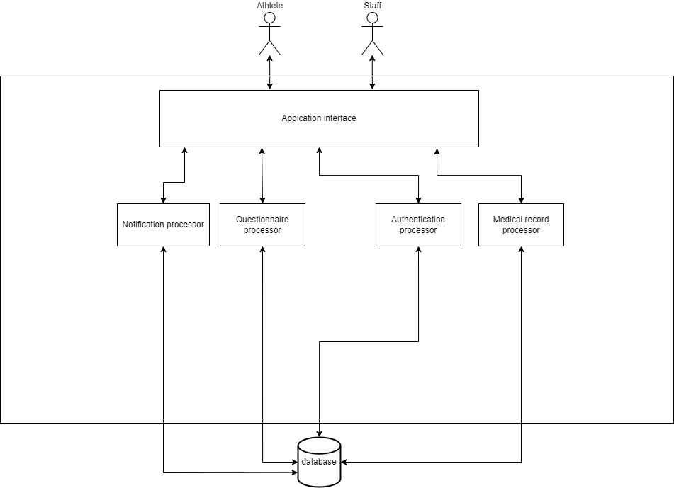

Figure 3.1: SIRA Systems architecture

Figure 3.1 shows the overviews of our system architecture (Sport Injury and Illness Recording Application). There are two types of the users, they are athlete and staff (medical team). The athletes can fill out a weekly injury or illness check questionnaire and submit data to firebase for storage and send to the medical team to track and view illnesses or injuries outside of athletes from training or competition. The staff can not only track and view athlete symptoms, but also create a record to save diagnoses of athlete symptoms in the firebase for decision-making by the organization. The system includes application interface, questionnaire processor, authentication processor, medical record processor, and notification processor. The application interface can only be used in phones with IOS operating system at this time. Authentication is to manage user accounts which can be separated into two categories, athletes and staff that athletes are allowed to save and read their data. The staff has the same rights as athletes but can be able to view illnesses and injuries data or weekly questionnaires of athletes taking. Doing questionnaire is accessible by athlete, which can be chosen from the application interface and the scores are calculated according to the Oslo Sports Trauma Research Center (OSTRC) and sent to firebase. Tracking will have access from medical team coming through the application interface to access athlete information. Forgot password can set the new password from the user send the email in the application interface. In order to connect to the database, the database manager serves as a controller. All statistical data can be stored in a database.

Figure 3.2: SIRA systems workflow

Figure 3.2 represents the workflow of all processes that specify whether athletes, staffs as well as the SIRA systems. The process starts from completion of questionnaire from athletes in order to save a result into the database (Firebase Firestore). After saved into the database, the system will send a notification of which questionnaire contains a total score over 25 points to staffs as a case. Then, staff will see the notification and receive whatever they want. Next, staffs have to complete a medical record regard to the received cases. After they finished the medical record, the system will notify the questionnaire status and advice messages for athlete from the staff who received. Then, athlete will receive the notification and they need to check the questionnaire status and react to advice messages for healing themselves. In addition, staffs can view the case and medical record history. Also, athletes can view the questionnaire history and advice messages.

## System Structure Chart

We produced the system structure chart, which illustrated the process all users would urge in terms of a diagram, in order to demonstrate how the SIRA system would be processed. The essential procedures for the recording system were analyzed and organized in the system structure chart. Additionally, a graphic and description have been used to explain the data that was needed to carry out the process.

|  |  |
| --- | --- |
|  | |
| Project : Sport Injury and Illness Recording Application  System : Recording system | Major Advisor : Asst. Prof. Dr. Charnyote Pluempitiwiriyawej |
| Description : This diagram represents the structure chart of main processes that both athlete and staff have to work as a procedure. | |

Figure 3.3: Structure chart of SIRA system

The detailed description of each subsystem is shown below:

1. **Authentication process** – Users have to authenticate to our system both registration and log in in order to access the interactive interfaces
   1. Register to the system – Fill in the personal information, username, and updated password to register to the system
   2. Log on to the authentication – Fill in the email and password in order to verify the authentication part and access to the interfaces
2. **Complete the questionnaire** – Athletes choose the questionnaire type, then complete whether questionnaire and complain
   1. Choosing the questionnaire type – Athletes choose the questionnaire type including health questionnaire, physical complain, or mental questionnaire
   2. Fill in the chosen questionnaire – Fill in or choose an answer in order to complete the questionnaire
3. **Notify cases** – Notification for staff in order to notify the case from athlete’s questionnaire after it is finished
   1. Receiving cases – Staff receive the notification from the system
4. **Complete the medical record** – Staffs have to fill in the medical record from case diagnostic
   1. Diagnostic the cases from athlete – Diagnostic whether health, body injury, and mental problem from athletes’ cases
   2. Choosing the medical record type – Staffs choose the appropriately medical record type to received cases
   3. Fill in the chosen medical record – Staffs complete the chosen medical record from the diagnostic result
5. **Notify status and advice messages** – The system will send the notification of status and advice message from staff who received their case
   1. Receiving status and advice messages – Athletes will receive the notification from staff in order to verify their questionnaire status and know how to react to their injury or illness
6. **Retrieve result questionnaire history** – Athletes can view their questionnaire history to check the past cases
   1. Query the result questionnaire history – Athletes query the desired questionnaire by given options or default settings
7. **Retrieve result records and cases** – Staffs can view their medical record history as well as the cases they received
   1. Query the result records and cases – Staffs query the desired record or cases by given options or default settings

## Process Analysis and Design

### Data Flow Diagram

Our data flow diagram represents the structure and analysis of the processes that can take place in our system and describes the system's flow. The graphic illustrates the processes that our users can carry out and how they create a process in order to produce an output, such as registration, login, completing a questionnaire, and other procedures. The diagram also shows the users who might be the main users, the data that is collected into the database, and the database that is needed for our systems.

|  |  |
| --- | --- |
|  | |
| Project : Sport Injury and Illness Recording Application  System : Recording system | Major Advisor : Asst. Prof. Dr. Charnyote Pluempitiwiriyawej |
| Description : This diagram represents how athletes and medical team are interacted with the SIRA application. | |

Figure 3.4: SIRA Data Flow Diagram Level 0

|  |  |
| --- | --- |
|  | |
| Project : Sport Injury and Illness Recording Application  System : Recording system | Major Advisor : Asst. Prof. Dr. Charnyote Pluempitiwiriyawej |
| Description : This diagram deep dives into level 1 of the data flow diagram which makes more clearly in each process through the SIRA application. | |

Figure 3.5: SIRA Data Flow Diagram Level 1

### Data Dictionary

A data dictionary is a way to document and describe Processes, Data Stores, and Data Elements (Data Flow) that occur in a Data Flow Diagram (DFD). It is composed of 3 parts as shown below.

* Process Descriptions
* Data Stores
* Data Elements

#### Process Description

This section will provide the detailed description of each process that exists in this system. It includes Inbound Data, Outbound Data, and Logic Summary.

Table 3.1: List of all Processes

| No. | Process | Name | Description |
| --- | --- | --- | --- |
| 1 | P1 | Authentication process | The process of authentication both register and log in to the system |
| 2 | P2 | Complete the questionnaire | Fill in the questionnaire in the system |
| 3 | P3 | Notify cases | Notification for medical team to examine the cases |
| 4 | P4 | Complete the medical record | Fill in the medical record from a diagnostic result |
| 5 | P5 | Notify status and advice messages | Notification for athlete to receive the questionnaire status and advice messages |
| 6 | P6 | Retrieve result questionnaire history | Query for retrieving the questionnaire result history description |
| 7 | P7 | Retrieve result records and cases | Query for retrieving the medical result history description and cases history description |

Table 3.2: Process Description of Log on to the application authentication

|  |  |
| --- | --- |
| Process Name | P1 – Authentication process |
| Description | The process of authentication both register and log in to the system |
| Inbound data | * Athlete’s username and password * Staff’s username and password * Athlete’s data * Staff’s data |
| Outbound Data | * User’s username and password * Athlete’s data * Staff’s data |
| Logic Summary | No subsystem |

Table 3.3: Process Description of Complete the questionnaire

|  |  |
| --- | --- |
| Process Name | P2- Complete the questionnaire |
| Description | Fill in the questionnaire in the system |
| Inbound data | * Answer & Score |
| Outbound Data | * Answer result * Total score * Preliminary advice message |
| Logic Summary | No subsystem |

Table 3.4: Process Description of Notify cases

|  |  |
| --- | --- |
| Process Name | P3- Notify cases |
| Description | Notification for medical team to examine the cases |
| Inbound data | * Total score over 25 * Questionnaire case description |
| Outbound Data | * Questionnaire case description and total score |
| Logic Summary | No subsystem |

Table 3.5: Process Description of Complete the medical record

|  |  |
| --- | --- |
| Process Name | P4- Complete the medical record |
| Description | Fill in the medical record from a diagnostic result |
| Inbound data | * Diagnostic result for athlete * Advice messages |
| Outbound Data | * Questionnaire status * Diagnostic results for athlete * Advice messages |
| Logic Summary | No subsystem |

Table 3.6: Process Description of Notify status and advice messages

|  |  |
| --- | --- |
| Process Name | P5- Notify status and advice messages |
| Description | Notification for athlete to receive the questionnaire status and advice messages |
| Inbound data | * Questionnaire status * Advice messages |
| Outbound Data | * Questionnaire status * Advice messages |
| Logic Summary | No subsystem |

Table 3.7: Process Description of Retrieve result questionnaire history

|  |  |
| --- | --- |
| Process Name | P6- Retrieve result questionnaire history |
| Description | Query for retrieving the questionnaire result history description |
| Inbound data | * Questionnaire history * Query for questionnaire history description |
| Outbound Data | * Questionnaire history description * Query for questionnaire history description |
| Logic Summary | No subsystem |

Table 3.8: Process Description of Retrieve result records and cases

|  |  |
| --- | --- |
| Process Name | P7- Retrieve result records and cases |
| Description | Query for retrieving the medical result history description and cases history description |
| Inbound data | * Query for case history * Query for medical record * Case history * Diagnostic record |
| Outbound Data | * Medical record description * Case history description * Query for case history * Query for medical record |
| Logic Summary | No subsystem |

#### Data Stores

This section describes the data stores that exist in the data flow diagram and consists of the Data Store Name, Description, Inbound Data, and Outbound Data.

Table 3.9: List of all Data Stores

| No. | Data Store | Name | Description |
| --- | --- | --- | --- |
| 1 | D1 | Users database | Keeping the staff and athlete data |
| 2 | D2 | Questionnaire database | Keeping the result of questionnaire from athletes |
| 3 | D3 | Medical record database | Keeping the result of diagnostic from medical team |
| 4 | D4 | Message database | Keeping the messages between athletes and staffs |

Table 3.10: Data Store Description of Users database

|  |  |
| --- | --- |
| Data Store Name | D1- Users database |
| Description | Keeping the staff and athlete data |
| Inbound data | * Athlete’s data * Staff’s data * User’s username and password |
| Outbound Data | * User verification |

Table 3.11: Data Store Description of Questionnaire database

|  |  |
| --- | --- |
| Data Store Name | D2- Questionnaire database |
| Description | Keeping the result of questionnaire from athletes |
| Inbound data | * Answer result * Total score * Questionnaire status * Query for questionnaire history description |
| Outbound Data | * Total score over 25 * Questionnaire case description * Questionnaire history * Questionnaire status |

Table 3.12: Data Store Description of Medical record database

|  |  |
| --- | --- |
| Data Store Name | D3- Medical record database |
| Description | Keeping the result of diagnostic from medical team |
| Inbound data | * Diagnostic results for athlete * Query for case history * Query for diagnostic record |
| Outbound Data | * Medical record * Case history |

Table 3.13: Data Store Description of Medical record database

|  |  |
| --- | --- |
| Data Store Name | D4- Message database |
| Description | Keeping the messages between athletes and staffs |
| Inbound data | * Advice messages |
| Outbound Data | * Advice messages |

#### Data Element

This section describes the data elements or data flows that exist in this system. The table below contains the list of all data elements belonging to their data element name, starting process/source/data store, and ending process/source/data store.

Table 3.14: List of All Data Elements

| SEQ | Data Element Name | From Process/Source/Data Store | To Process/Source/Data Store |
| --- | --- | --- | --- |
| 1 | Athlete’s data | Athlete | P1 |
| 2 | Athlete’s data | P1 | D1 |
| 3 | Staff’s data | Medical Team | P1 |
| 4 | Staff’s data | P1 | D1 |
| 5 | Athlete’s username & password | Athlete | P1 |
| 6 | Staff’s username & password | Medical Team | P1 |
| 7 | User’s username & password | P1 | D1 |
| 8 | User verification | D1 | P1 |
| 9 | Answer & Score | Athlete | P2 |
| 10 | Preliminary advice message | P2 | Athlete |
| 11 | Answer result | P2 | D2 |
| 12 | Total score | P2 | D2 |
| 13 | Total score over 25 | D2 | P3 |
| 14 | Questionnaire case description | D2 | P3 |
| 15 | Questionnaire case description & Total score | P3 | Medical Team |
| 16 | Diagnostic results for athlete | Medical Team | P4 |
| 17 | Advice messages | Medical Team | P4 |
| 18 | Questionnaire status | P4 | D2 |
| 19 | Advice messages | P4 | D4 |
| 20 | Diagnostic results for athlete | P4 | D3 |
| 21 | Questionnaire status | D2 | P5 |
| 22 | Advice messages | D4 | P5 |
| 23 | Questionnaire status | P5 | Athlete |
| 24 | Advice messages | P5 | Athlete |
| 25 | Query for questionnaire history description | Athlete | P6 |
| 26 | Query for questionnaire history description | P6 | D2 |
| 27 | Questionnaire history | D2 | P6 |
| 28 | Questionnaire history description | P6 | Athlete |
| 29 | Query for case history | Medical Team | P7 |
| 30 | Query for diagnostic record | Medical Team | P7 |
| 31 | Query for case history | P7 | D3 |
| 32 | Query for diagnostic record | P7 | D3 |
| 33 | Case history | D3 | P7 |
| 34 | Diagnostic record | D3 | P7 |
| 35 | Case history description | P7 | Medical Team |
| 36 | Diagnostic record description | P7 | Medical Team |

## Database Analysis and Design

The systems are created with interactive together which contain the entities, relationships, and attributes. Each entity will contain its data as attributes that represent the needed data as well as primary key and foreign key which can be used in SQL. The attribute contains the data that is relevant to them which some data can be null, and some data must fill in. However, this design and analysis are simply examples but cover all main users and data in our game system.

### ER-Diagram

|  |  |
| --- | --- |
|  | |
| Project: Sport Injury and Illness Recording Application  System: Recording system | Major Advisor: Asst. Prof. Dr. Charnyote Pluempitiwiriyawej |
| Description: This is ER-Diagram of SIRA including four entities that are superclass. User class has two subclasses including “Athlete” and “Staff”. Questionnaire class has two subclasses including “HealthQuestionnaire” and “PhysicalQuestionnaire”. MedicalRecord class has two subclasses including “IllnessRecord” and “InjuryRecord”. Message is weak entity from Medical Record. | |

Figure 3.6: Conceptual ER-Diagram of SIRA Database

### Relational Schema

This section describes the attributes of the tables in the database. The attribute notation is shown below.

* **Attributes** – which are bold and underlined are the Primary Keys
* *Attributes* – which are Italic are the Foreign Keys
* ***Attributes*** – which are bold, italic and underlined are both Primary Keys and Foreign Keys

Tables in this system can be divided into 3 groups as follows:

* Master File Table
* Base File Table
* Transaction File Table

Table 3.15: List of all Tables in Our System Database

| Table# | Table Name | Table Type | Description |
| --- | --- | --- | --- |
| 1 | Athlete | Master | It is the subclass that collects the information of athlete. |
| 2 | Staff | Master | It is the subclass that collects the information of staff. |
| 3 | HealthQuestionnaire | Base | It is the subclass that collects all of health questionnaires that athletes do. |
| 4 | PhysicalQuestionnaire | Base | It is the subclass that collects all of physical questionnaires that athletes do. |
| 5 | IllnessRecord | Base | It is the subclass that collects all of illness records that staffs do. |
| 6 | InjuryRecord | Base | It is the subclass that collects all of injury records that staffs do. |
| 7 | Message | Base | This table is the weak entity that collects the messages that occur when the staff makes a record for the athlete. |

1. Relational Schema of Master File Tables

**Athlete**

|  |  |  |  |  |  |  |  |
| --- | --- | --- | --- | --- | --- | --- | --- |
| **uid** | **athlete_no** | username | password | firstname | lastname | sportType | birthdate |

|  |  |  |  |  |  |
| --- | --- | --- | --- | --- | --- |
| department | weight | height | email | age | gender |

**Staff**

|  |  |  |  |  |  |  |  |
| --- | --- | --- | --- | --- | --- | --- | --- |
| **uid** | **staff_no** | username | password | firstname | lastname | stafftType | birthdate |

|  |  |
| --- | --- |
| department | email |

1. Relational Schema of Base File Tables

**HealthQuestionnaire**

|  |  |  |  |  |
| --- | --- | --- | --- | --- |
| **questionnaireNo** | ***athleteNo*** | questionnaireType | totalPoint | caseFinished |

|  |  |  |  |  |  |  |  |
| --- | --- | --- | --- | --- | --- | --- | --- |
| caseRecieved | healthSymptom | doDate | ***staff_no_received*** | Q1 | Q2 | Q3 | Q4 |

**PhysicalQuestionnaire**

|  |  |  |  |  |
| --- | --- | --- | --- | --- |
| **questionnaireNo** | *athleteNo* | questionnaireType | totalPoint | caseFinished |

|  |  |  |  |  |  |  |  |
| --- | --- | --- | --- | --- | --- | --- | --- |
| caseRecieved | bodypart | doDate | *staff_no_received* | Q1 | Q2 | Q3 | Q4 |

**IllnessRecord**

|  |  |  |  |  |  |  |
| --- | --- | --- | --- | --- | --- | --- |
| **report_id** | *staff_uid* | *athlete_no* | report_type | sport_event | DoingDate | affected_system_code |

|  |  |  |  |  |  |
| --- | --- | --- | --- | --- | --- |
| affected_system | diagnosis | illness_cause | mainSymtoms | mainSymptomsCode | illness_cause_code |

|  |  |
| --- | --- |
| occurred_date | no_day |

**InjuryRecord**

|  |  |  |  |  |  |  |
| --- | --- | --- | --- | --- | --- | --- |
| **report_id** | *staff_uid* | *athlete_no* | report_type | sport_event | DoingDate | round_heat_training |

|  |  |  |  |  |  |
| --- | --- | --- | --- | --- | --- |
| injuryBody | injuryBodyCode | injuryCause | injuryCauseCode | injuryDateTime | injuryTypeCode |

|  |  |
| --- | --- |
| injuryType | no_day |

**Message**

|  |  |  |  |  |
| --- | --- | --- | --- | --- |
| **messageNo** | messageDescription | messageDateTime | *athleteNo* | *staffUID* |

### File Structure

This section shows the details of each file component including field name, field description, field data type, field length, null value, primary key and foreign key.

Table 3.16: File Structure of Athlete

|  |  |  |  |  |  |  |  |  |
| --- | --- | --- | --- | --- | --- | --- | --- | --- |
| Table Name : | Athlete | | | | | | Table#**1** | |
| Table Type : | Master | | | | | | | |
| Description : | Storing the information of athletes. | | | | | | | |
| Field Name | | Type | Length | Description | Key | Reference | | Null |
| uid | | varchar | 28 | User’s ID | PK |  | | NOT |
| athleteNo | | varchar | 11 | Athlete’s ID | PK |  | | NOT |
| username | | varchar | 500 | Athlete’s username |  |  | | NOT |
| password | | varchar | 500 | Athlete’s password |  |  | | NOT |
| firstname | | varchar | 500 | Athlete’s firstname |  |  | | NOT |
| lastname | | varchar | 500 | Athlete’s lastname |  |  | | NOT |
| sportType | | varchar | 500 | Athlete’s sport type |  |  | | NOT |
| birthdate | | DATE | 100 | Athlete’s birth date |  |  | | NOT |
| department | | varchar | 500 | User’s department |  |  | | NOT |
| weight | | double | 11 | Athlete’s weight |  |  | | NOT |
| height | | double | 11 | Athlete’s height |  |  | | NOT |
| age | | int | 2 | Athlete’s age |  |  | | NOT |
| gender | | varchar | 6 | Athlete’s gender |  |  | | NOT |
| email | | varchar | 500 | Athlete’s email |  |  | | NOT |
|  | | Total | 3669 | Bytes |  |  | |  |

|  |  |  |  |  |  |  |  |  |
| --- | --- | --- | --- | --- | --- | --- | --- | --- |
| Table Name : | Staff | | | | | | Table#**2** | |
| Table Type : | Master | | | | | | | |
| Description : | Storing the information of staffs. | | | | | | | |
| Field Name | | Type | Length | Description | Key | Reference | | Null |
| uid | | varchar | 28 | User’s ID | PK |  | | NOT |
| staffNo | | varchar | 11 | Staff’s ID | PK |  | | NOT |
| username | | varchar | 500 | Staff’s username |  |  | | NOT |
| password | | varchar | 500 | Staff’s password |  |  | | NOT |
| firstname | | varchar | 500 | Staff’s firstname |  |  | | NOT |
| lastname | | varchar | 500 | Staff’s lastname |  |  | | NOT |
| staffType | | varchar | 500 | Staff’s type |  |  | | NOT |
| birthdate | | DATE | 100 | Staff’s birth date |  |  | | NOT |
| department | | varchar | 500 | User’s department |  |  | | NOT |
| email | | varchar | 500 | Staff’s email |  |  | | NOT |
|  | | Total | 3639 | Bytes |  |  | |  |

Table 3.17: File Structure of Staff

Table 3.18: File Structure of Health questionnaire

|  |  |  |  |  |  |  |  |  |
| --- | --- | --- | --- | --- | --- | --- | --- | --- |
| Table Name : | HealthQuestionnaire | | | | | | Table#**3** | |
| Table Type : | Base | | | | | | | |
| Description : | Storing the athlete’s health questionnaire answers and calculate the score | | | | | | | |
| Field Name | | Type | Length | Description | Key | Reference | | Null |
| questionnaireNo | | varchar | 12 | Questionnaire’s ID | PK |  | | NOT |
| athleteNo | | varchar | 28 | Athlete’s user ID | FK | Athlete | | NOT |
| questionnaireType | | varchar | 500 | Questionnaire’s type |  |  | | NOT |
| totalPoint | | int | 3 | Total of points |  |  | | NOT |
| caseFinished | | varchar | 500 | Check this case finish or not |  |  | | NOT |
| caseReceived | | varchar | 500 | Check this case receive or not |  |  | | NOT |
| healthSymptom | | varchar | 500 | Athlete’s health symptom |  |  | | NOT |
| doDate | | DATETIME | 100 | Questionnaire’s do date and time |  |  | | NOT |
| staff_no_received | | varchar | 500 | Staff’s user ID who receives the athlete’s case | FK | Staff | | NOT |
| Q1 | | int | 11 | Question 1 point |  |  | | NOT |
| Q2 | | int | 11 | Question 2 point |  |  | | NOT |
| Q3 | | int | 11 | Question 3 point |  |  | | NOT |
| Q4 | | int | 11 | Question 4 point |  |  | | NOT |
|  | | Total | 2687 | Bytes |  |  | |  |

Table 3.19: File Structure of Physical questionnaire

|  |  |  |  |  |  |  |  |  |
| --- | --- | --- | --- | --- | --- | --- | --- | --- |
| Table Name : | PhysicalQuestionnaire | | | | | | Table#**4** | |
| Table Type : | Base | | | | | | | |
| Description : | Storing the athlete’s physical questionnaire answers and calculate the score | | | | | | | |
| Field Name | | Type | Length | Description | Key | Reference | | Null |
| questionnaireNo | | varchar | 12 | Questionnaire’s ID | PK |  | | NOT |
| athleteNo | | varchar | 28 | Athlete’s user ID | FK | Athlete | | NOT |
| questionnaireType | | varchar | 500 | Questionnaire’s type |  |  | | NOT |
| totalPoint | | int | 3 | Total of points |  |  | | NOT |
| caseFinished | | varchar | 500 | Check this case finish or not |  |  | | NOT |
| caseReceived | | varchar | 500 | Check this case receive or not |  |  | | NOT |
| bodyPart | | varchar | 500 | Athlete’s body part |  |  | | NOT |
| doDate | | DATETIME | 100 | Questionnaire’s do date and time |  |  | | NOT |
| staff_no_received | | varchar | 500 | Staff’s user ID who receives the athlete’s case | FK | Staff | | NOT |
| Q1 | | int | 11 | Question 1 point |  |  | | NOT |
| Q2 | | int | 11 | Question 2 point |  |  | | NOT |
| Q3 | | int | 11 | Question 3 point |  |  | | NOT |
| Q4 | | int | 11 | Question 4 point |  |  | | NOT |
|  | | Total | 2687 | Bytes |  |  | |  |

Table 3.20: File Structure of Illness record

|  |  |  |  |  |  |  |  |  |
| --- | --- | --- | --- | --- | --- | --- | --- | --- |
| Table Name : | IllnessRecord | | | | | | Table#**5** | |
| Table Type : | Base | | | | | | | |
| Description : | Storing the illness record that staff do. | | | | | | | |
| Field Name | | Type | Length | Description | Key | Reference | | Null |
| report_id | | varchar | 12 | Report’s ID | PK |  | | NOT |
| staff_uid | | varchar | 28 | Staff’s user ID | FK | Staff | | NOT |
| athlete_no | | varchar | 11 | Athlete’s ID |  |  | | NOT |
| report_type | | varchar | 500 | Report’s type |  |  | | NOT |
| sport_event | | varchar | 500 | Sport that causes illness in the event |  |  | | NOT |
| DoingDate | | varchar | 500 | Staff’s do date |  |  | | NOT |
| affected_system | | varchar | 500 | Affected system that happen to athlete |  |  | | NOT |
| affected_system_code | | int | 2 | Affected system code |  |  | | NOT |
| diagnosis | | varchar | 500 | The identification of the nature of an illness or other problem by examination |  |  | | NOT |
| illness_cause | | varchar | 500 | The cause of illness |  |  | | NOT |
| illness_cause_code | | int | 2 | Illness’s cause code |  |  | | NOT |
| mainSymptoms | | varchar | 500 | Main Symptoms diagnosed |  |  | | NOT |
| mainSymptomsCode | | int | 2 | Main Symptoms code |  |  | | NOT |
| occurred_date | | DATETIME | 100 | The date and time that occur illness |  |  | | NOT |
| no_day | | varchar | 100 | The day to rest or stop training |  |  | | NOT |
|  | | Total | 3757 | Bytes |  |  | |  |

Table 3.21: File Structure of Injury record

|  |  |  |  |  |  |  |  |  |
| --- | --- | --- | --- | --- | --- | --- | --- | --- |
| Table Name : | InjuryRecord | | | | | | Table#**6** | |
| Table Type : | Base | | | | | | | |
| Description : | Storing the injury record that staff do. | | | | | | | |
| Field Name | | Type | Length | Description | Key | Reference | | Null |
| report_id | | varchar | 12 | Report’s ID | PK |  | | NOT |
| staff_uid | | varchar | 28 | Staff’s user ID | FK | Staff | | NOT |
| athlete_no | | varchar | 11 | Athlete’s ID |  |  | | NOT |
| report_type | | varchar | 500 | Report’s type |  |  | | NOT |
| sport_event | | varchar | 500 | Sport that causes injury in the event |  |  | | NOT |
| DoingDate | | varchar | 500 | Staff’s do date |  |  | | NOT |
| injuryBody | | varchar | 500 | The athlete’s body part that injuries |  |  | | NOT |
| injuryBodyCode | | int | 2 | Injury Body code |  |  | | NOT |
| round_heat_training | | varchar | 500 | Round, heat or training during an injury |  |  | | NOT |
| injuryCause | | varchar | 500 | The cause of injury |  |  | | NOT |
| injuryCauseCode | | int | 2 | Injury’s cause code |  |  | | NOT |
| injuryDateTime | | DATETIME | 100 | Injury’s date and time |  |  | | NOT |
| injuryType | | varchar | 500 | Injury’s type |  |  | | NOT |
| injuryTypeCode | | int | 2 | Injury’s type code |  |  | | NOT |
| no_day | | varchar | 100 | The day to rest or stop training |  |  | | NOT |
|  | | Total | 3757 | Bytes |  |  | |  |

Table 3.22: File Structure of Illness record

|  |  |  |  |  |  |  |  |  |
| --- | --- | --- | --- | --- | --- | --- | --- | --- |
| Table Name : | IllnessRecord | | | | | | Table#**5** | |
| Table Type : | Base | | | | | | | |
| Description : | Storing the illness record that staff do. | | | | | | | |
| Field Name | | Type | Length | Description | Key | Reference | | Null |
| report_id | | varchar | 12 | Report’s ID | PK |  | | NOT |
| staff_uid | | varchar | 28 | Staff’s user ID | FK | Staff | | NOT |
| athlete_no | | varchar | 11 | Athlete’s ID |  |  | | NOT |
| report_type | | varchar | 500 | Report’s type |  |  | | NOT |
| sport_event | | varchar | 500 | Sport that causes illness in the event |  |  | | NOT |
| DoingDate | | varchar | 500 | Staff’s do date |  |  | | NOT |
| affected_system | | varchar | 500 | Affected system that happen to athlete |  |  | | NOT |
| affected_system_code | | int | 2 | Affected system code |  |  | | NOT |
| diagnosis | | varchar | 500 | The identification of the nature of an illness or other problem by examination |  |  | | NOT |
| illness_cause | | varchar | 500 | The cause of illness |  |  | | NOT |
| illness_cause_code | | int | 2 | Illness’s cause code |  |  | | NOT |
| mainSymptoms | | varchar | 500 | Main Symptoms diagnosed |  |  | | NOT |
| mainSymptomsCode | | int | 2 | Main Symptoms code |  |  | | NOT |
| occurred_date | | DATETIME | 100 | The date and time that occur illness |  |  | | NOT |
| no_day | | varchar | 100 | The day to rest or stop training |  |  | | NOT |
|  | | Total | 3757 | Bytes |  |  | |  |

Table 3.23: File Structure of Message

|  |  |  |  |  |  |  |  |  |
| --- | --- | --- | --- | --- | --- | --- | --- | --- |
| Table Name : | Message | | | | | | Table#**7** | |
| Table Type : | Base | | | | | | | |
| Description : | Storing the message when staff do the record and want to give message to athlete. | | | | | | | |
| Field Name | | Type | Length | Description | Key | Reference | | Null |
| messageNo | | varchar | 11 | Message’s ID | PK |  | | NOT |
| messageDescription | | varchar | 500 | Message description |  |  | | NOT |
| messageDateTime | | DATETIME | 100 | Message’s date and time |  |  | | NOT |
| athleteNo | | varchar | 11 | Athlete’s ID | FK | Athlete | | NOT |
| staffUID | | varchar | 28 | Sport that causes illness in the event | FK | Staff | | NOT |
|  | | Total | 650 | Bytes |  |  | |  |

## I/O Design

This section explains the design of the Input and Output User Interface. The section consists of two parts, the interface design and the transition diagram showing transition through the system.

### Interface Design

Figure 3.7: Register and Login

According to Figure 3.7, users must sign in in login page and sign up in register page to create an account.

Figure 3.8 Staff/Athlete Homepage

According to Figure 3.8, both interfaces contain staff homepage (left picture) and athlete homepage (right picture). When user’s login successfully, user can go to homepage first. If you are athlete, your homepage has the green bottom bar that has home, search, and history button. If you are staff, your homepage has the blue bottom bar that has home, history, and cases button

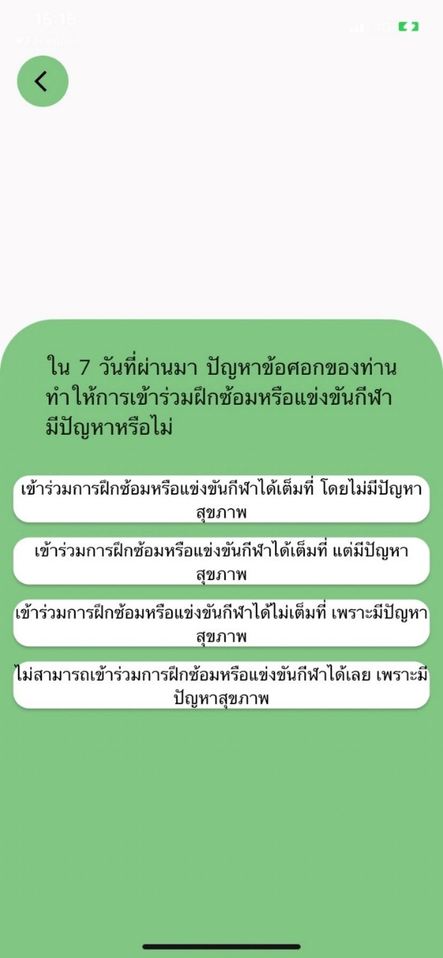

Figure 3.9: Questionnaire page

According to Figure 3.9, athletes have the three questionnaire buttons in their homepage that are health questionnaire, physical complain, and mental questionnaire.

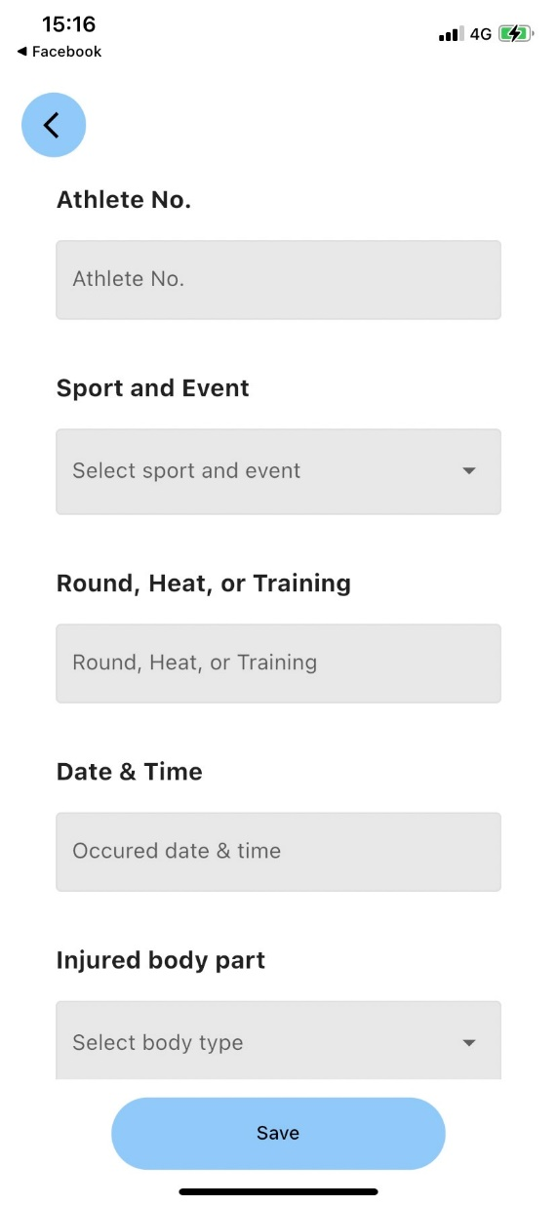

Figure 3.10: Recording page

According to Figure 3.10, athletes have the two recording buttons in their homepage that are illness and injury record.

Figure 3.11: Notification page

According to Figure 3.11, both interfaces represent the athlete notification page (left picture) and the staff notification page (right page). For notification page, Athletes and staffs can see the top right button in homepage that have bell button, it is notification button. The alarm button properties of both parties are different as follows:

* **Athlete’s notification (Left picture)**

It notifies the message that the staff or medical team sent to that athlete.

* **Staff’s notification (Right picture)**

It notifies the cases that the athlete has completed the questionnaire and the points are due to be recorded by the medical team which the medical team can accept cases by pressing the plus button and reading the description above the button.

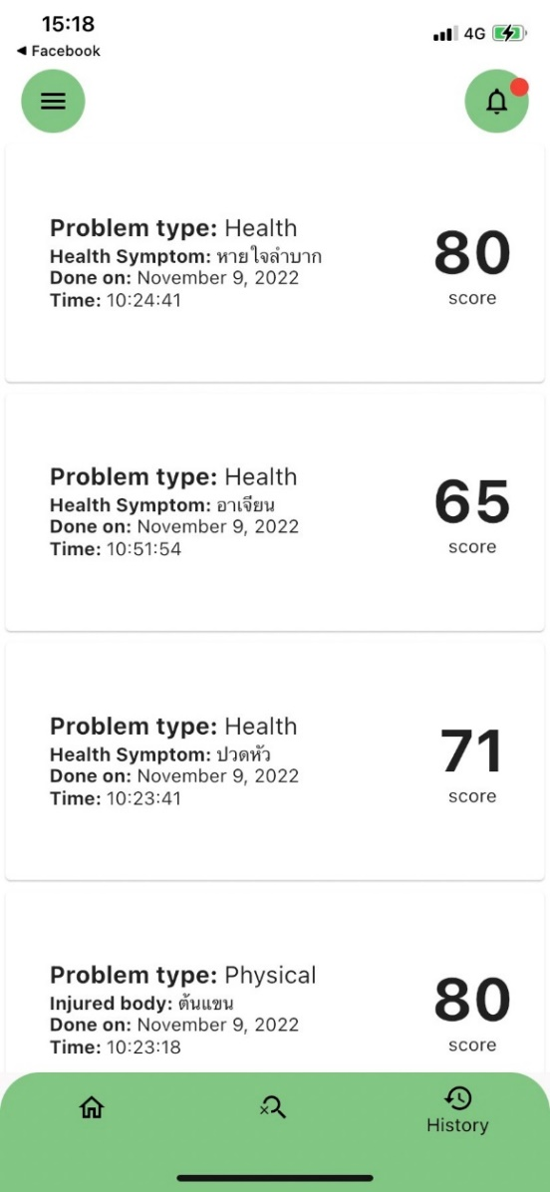 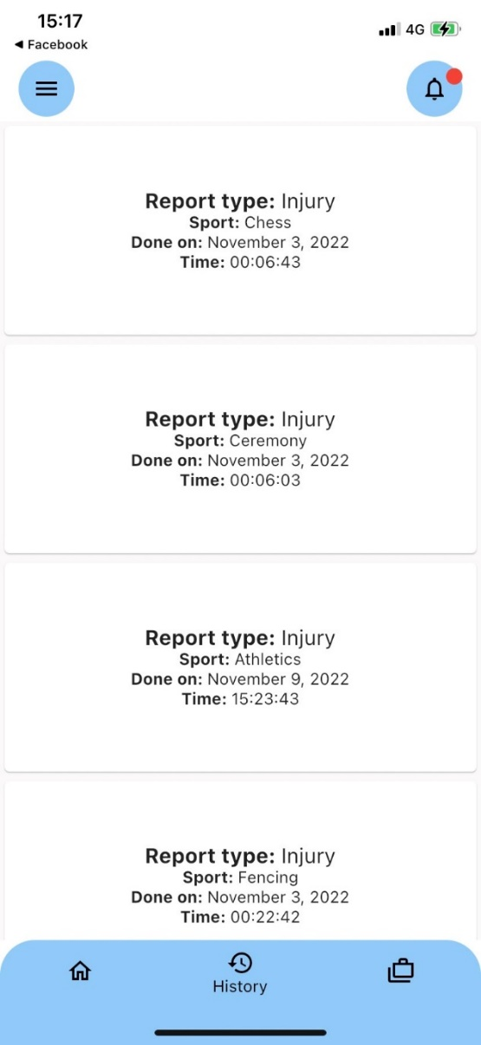

Figure 3.12: History page

According to Figure 3.12, both interfaces represent the athlete history page (left picture) and the staff history page (right picture). Athlete and staff have the history button that each position when pressing the history data button is different as follows:

* **Athlete’s history (Left picture)**

It shows the history of the questionnaires that athletes do it. It shows the questionnaire score, questionnaire type, health symptom or injured body, and date and time of the questionnaire.

* **Staff’s history (Right picture)**

It shows report completed by staff which shows data card with report type, sport, and date and time of the finished report.

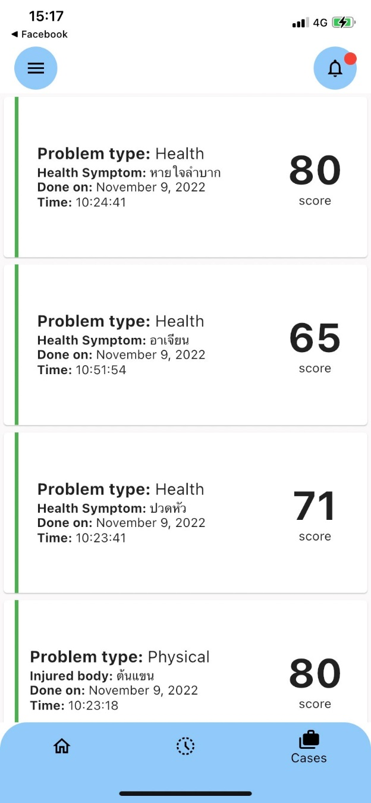

Figure 3.13: Staff’s case page

Figure 3.13 shows the cases that staff receive in the notification. When staff click plus button in notification, the received case will show in the case page with red line tag. If staffs finish the received case, the case will change the red line tag to green line tag. Cards in the case page show several information, for instance, the received case history, case’s score, problem type, and others.

CHAPTER 4

# Implementation

## Hardware and System Environment

### Environment for implementing the SIRA application

* Operating System
  + Android – For downloading and using the application
  + IOS – For downloading and using the application
* Component
  + Internet

### Environment for developing the SIRA application

* Operating System
  + Window 10 – For developing the application of Android
  + MacOS – For developing the application of IOS
* Web Server Software
* Editor
* Database Management System (DBMS)
  + FirebaseFirestore
* Programming and Scripting Tools
  + Visual Studio Code
  + XCode
* Components

## Implementation Guide and Techniques

### <Guide/Technique/Know-how>

### < Guide/Technique/Know-how>

CHAPTER 5

# Testing and Evaluation

## Unit Tests

For the unit tests, we selected some important and critical processes for formal unit testing. The selected processes include:



### Test Performed on <Process Number> <Process Name>

Table 5.1: <Test Name>

|  |  |  |
| --- | --- | --- |
| Operation Performed | Condition Tested | Actual Result |
|  |  |  |
|  |  |  |
|  |  |  |
|  |  |  |
|  |  |  |

### Test Performed on <Process Number> <Process Name>

Table 5.2: <Test Name>

|  |  |  |
| --- | --- | --- |
| Operation Performed | Condition Tested | Actual Result |
|  |  |  |
|  |  |  |
|  |  |  |
|  |  |  |

## System Integration Test

This activity is performed after the system is completely integrated. The purpose of this testing is to check whether the system can operate correctly according to the required functions or not.

### Test Scenario

In order to test all functional aspects of the system thoroughly, we had set up a test scenario which consisted of phases as shown below.

Moreover, the test scenario can be used as a user guideline because it covers all the steps necessary in order to use our system. The details of each phase are shown in the next section.

#### 

#### 

#### 

#### 

#### 

CHAPTER 6

# Conclusions

## Benefits

### Benefits to Project Developers

### Benefits to Users

## Problems and Limitations

## Future Work

REFERENCES

|  |  |
| --- | --- |
| [1] | International Olympic Committee (IOC), "London 2012 Olympic Summer Games Injury & Illness Surveillance Study," 2012. [Online]. Available: https://stillmed.olympic.org/media/Document%20Library/OlympicOrg/Games/Summer-Games/Games-London-2012-Olympic-Games/Anti-doping-and-Medical-Rules/Injury-and-Illness-Surveillance-Study-London-2012.pdf. [Accessed 20 November 2022]. |
| [2] | K. Kaewkul, K. Chaijenkij and S. Tongsai, "Validity and Reliability of the Oslo Sports Trauma Research Center (OSTRC) Questionnaire on Overuse Injury and Health Problem in Thai Version," *J Med Assoc Thai 2021,* vol. 104, no. 1, pp. 105-113, 21 August 2020. |
| [3] | L. Engebretsen and R. Bahr, "The main aim of Oslo Sports Trauma Research Center is to prevent injuries and other health problems in sports - through research on risk factors, injury mechanisms and prevention methods," 15 October 2021. [Online]. Available: https://www.med.uio.no/klinmed/english/research/groups/oslo-sports-trauma-research-center-ostrc/index.html. [Accessed 24 November 2022]. |
| [4] | B. Clarsen, R. Bahr and G. Myklebust, "Improved reporting of overuse injuries and health problems in sport: an update of the Oslo Sport Trauma Research Center questionnaires," *Br J Sports Med,* vol. 54, pp. 390-396, 14 February 2020. |
| [5] | B. Clarsen, R. Bahr and G. Myklebust, "Development and validation of a new methodfor the registration of overuse injuries in sportsinjury epidemiology," *Br J Sports Med,* vol. 00, pp. 1-8, 4 October 2012. |
| [6] | B. P. Raysmith and M. K. Drew, "Performance success or failure is influenced by weeks lost to injury and illness in elite Australian track and field athletes: A 5-year prospective study," *J Sci Med Sport,* vol. 19, no. 10, pp. 778-783, 1 October 2016. |
| [7] | L. Engebretsen, T. Soligard and K. Steffen, "Sports injuries and illnesses during the LondonSummer Olympic Games 2012," *Br J Sports Med,* vol. 0, pp. 1-8, 20 March 2013. |

BIOGRAPHIES

|  |  |
| --- | --- |
| NAME | Mr. Krissanapong Palakham |
| INSTITUTIONS ATTENDED | Assumption College Thonburi, 2019:  High School Diploma  Mahidol University, 2023:  Bachelor of Science (ICT) |
|  |  |
| NAME | Mr. Pongsakorn Piboonpongpun |
| INSTITUTIONS ATTENDED | Assumption College Thonburi, 2019:  High School Diploma  Mahidol University, 2023:  Bachelor of Science (ICT) |
|  |  |
| NAME | Mr. Rathakit Sriprachayanun |
| INSTITUTIONS ATTENDED | Assumption College, 2019:  High School Diploma  Mahidol University, 2023:  Bachelor of Science (ICT) |